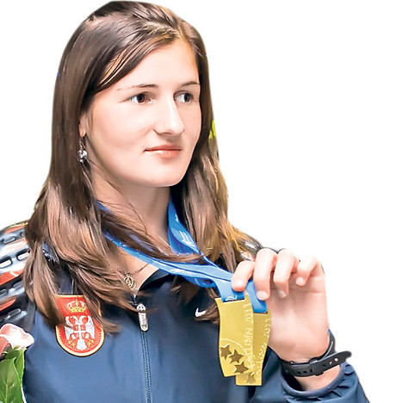

TERZIĆ Amela ____

Rođena/Born: 2.I 1993. Priboj
Visina/Height: 168cm
Težina/Weight: 51kg

Član/Member: AK Novi Pazar

Trener/Coach: Rifat Zilkić

Razvoj/Year Progression
(1500/3000m)

2007- 4:48,37
2008- 4:25,92/9:33,63
2009- 4:16,71/9:17,90
2010- 4:13,46/9:20,32
2011- 4:15,40/9:17,61
2012- 4:07,59/9:16,59
2013- 4:05,69/9:18,60
2014- 4:07,34/9:11,64
2015- 4:04,77/8:57,20
2016- 4:05,53/9:10,12
2017- 4:06,29/9:15,85
2018- 4:10,22/9:32,88
2019- 4:08,48i/10:53,24

Lični rekordi/PBS
400- 56,65 (2017); 800- 1:59,90 (2015); 1000- 2:39,79 (2012); milja/mile- 4:33,46 (2014); 2000- 5:55,62 (2014); dvorana/indoor: 800- 2:03,27 (2017); 1500- 4:08,48 (2019); 3000- 9:03,39 (2016);

Olimpijske igre/Olympic Games
2016- 800 2:03,81 sf (2:00,99 Q); 1500 (4:13,92 Q);

Svetsko prvenstvo/World Championship
2013- 1500 (4:27,89 Q); 2015- 1500 (4:13,92 sf; 4:06,07 Q); 2017- 1500 (4:08,55 Q);

Svetsko prvenstvo u krosu/World Cross-Country Championship
2011- juniorke 6km XXII;

Univerzijada/Universiade
2017- 800 (2:07,54 sf; 2:04,51 Q); 1500 (4:19,18; sf. 4:19,59) GOLD;

Prvenstvo Evrope/European Championship
2014- 1500 (4:19,11 XII, 4:11,75 sf); 2016- 1500 4:37,70 XII (sf. 4:09,71); 2018- 1500 4:17,22 Q;

Prvenstvo Evrope u dvorani/European Indoor Championship
2015- 3000 (9:17,73 Q); 2017- 1500 (4:25,15 VIII; sf. 4:10,35); 2019- 1500 (4:24,20 IX, sf. 4:16,51);

Prvenstvo Evrope u krosu/European Cross-Country Championship
2009- juniorke 4km XII; 2010- juniorke 4km SILVER; 2011- juniorke 4km BRONZ; 2012- juniorke 4km GOLD; 2013- ml.seniorke 6km SILVER; 2014- ml.seniorke 6km X; 2015- 6km ml.seniorke BRONZ;

Svetsko prvenstvo za juniorke/World Junior Championship
2010- 1500 (4:19,03; 4:13,46 sf) VIII; 2012- 1500 (4:07,59; 4:11,53 sf) SILVER;

Prvenstvo Evrope za juniorke/European Junior Championship
2009- 1500 (4:23,99; 4:20,60 sf) IX; 3000 (9:22,44) VI; 2011- 1500 (4:15,40) GOLD; 3000 (9:17,61) GOLD;

Svetsko prvenstvo za mlađe juniorke/World Youth Championship
2009- 1500 (4:16,71; 4:18,04 sf) BRONZ; 3000 (9:17,90) BRONZ;

Evropske igre mladih/EYOF
2009- 1500 (4:22,46) GOLD;

Mediteranske igre/Mediterranean Games
2018- 800 2:08,38 Q); 1500 (4:19,73 VII);

Prvakinja Balkana/Balkan Games Champion
2008- 1500 (4:25,92) ml.juniorke; 2009- 800 (2:08,40) i 1500 (4:20,64) za juniorke; 1500- 4:29,47 ml.juniorke; kros- juniorke; 2010- 800 (2:07,93) ml.juniorke; 2011- kros- juniorke; 2012- 1500 (4:24,06), 3000 (9:44,64); kros- juniorke; 2013- 1500 (4:16,27), 3000 (9:18,60); kros (ml.seniorke 8km); 2014- kros (ml.seniorke 8km); 2017- 800 (2:07,25); 1500 (4:19,00)
2018- 1500 (4:17,24 indoor); 2019- 1500 (4:15,04 indoor);

Reprezentativac Balkana/Balkan Team Member
2013- 4:29,44 IV; 2017- 5:56,54 (2km) IV (Angers, France);

Prvakinja Srbije/National Champion
2009- 800 (2:05,61); 1500 (4:23,82); 2010- 1500 (4:20,18); kros; 2011- 800 (2:05,16); 1500 (4:25,29); kros; 2012- kros; 2013- 800 (2:06,58); 1500 (4:26,16); kros; 2014- 800 (2:08,11); 1500 (4:13,53); kros; 2015- kros; 2016- 800- (2:06,97); 1500 (4:18,51); 2017- 800 (2:04,30); 1500 (4:25,63); 2018- 800 (2:04,96); 1500 (4:25,87); 2019- 1500 (4:25,35 indoor);

Državni rekordi/National Records
800- 1:59,90 (2015); ind- 2:03,27 (2017); 1000- 2:39,79 (2012); 1500- 4:07,59 (2012); 4:05,69 (2013); 4:04,77 (2015); ind- 4:10,35 (2017); 4:08,48 (2019); 2000- 5:55,62 (2014); 3000i- 9:03,39 (2016);

DOKUMENTACIJA
Ljubiša Gajić (Jagodina)
ATFS Serbia

