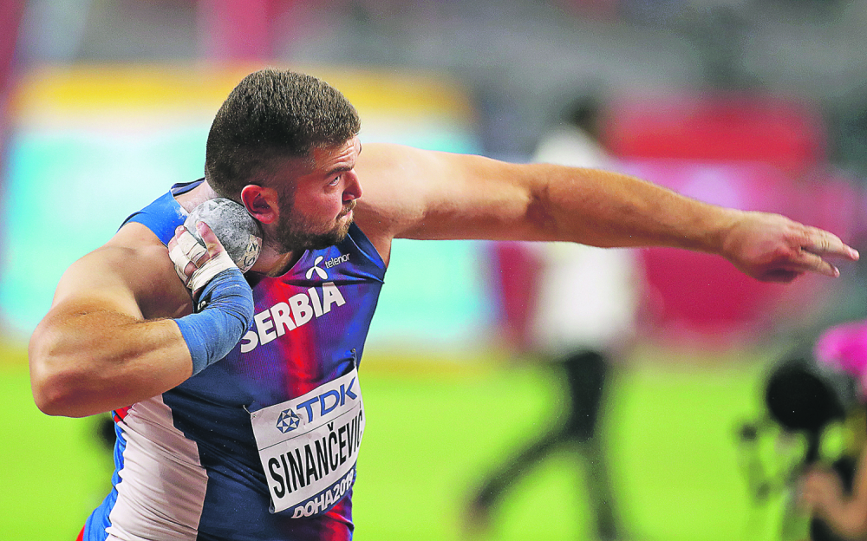

SINANČEVIĆ Armin ____

Rođen/Born: 14.VIII 1996. Brodarevo
Visina/Height: 192cm
Težina/Weight: 110kg

Član/Member: Polet (Prijepolje)

Trener/Coach: Savo Pušica

Razvoj/Year Progression
(Kugla/SP)

2015- 15,63
2016- 18,77
2017- 18,53
2018- 18,93
2019- 21,51/19,80i

Lični rekordi/PBS
Disk/DT- 44,97 (2018); Kugla/SP- 19,80 (indoor, 2019);

Svetsko prvenstvo/Worls Championship
2019. bez rezultata u finalu/nm in final race; 21,51 Q;

Prvak Srbije/Serbian Champion
2016. 17,28; 2017. 18,53;

DOKUMENTACIJA
Ljubiša Gajić (Jagodina)
ATFS Serbia

