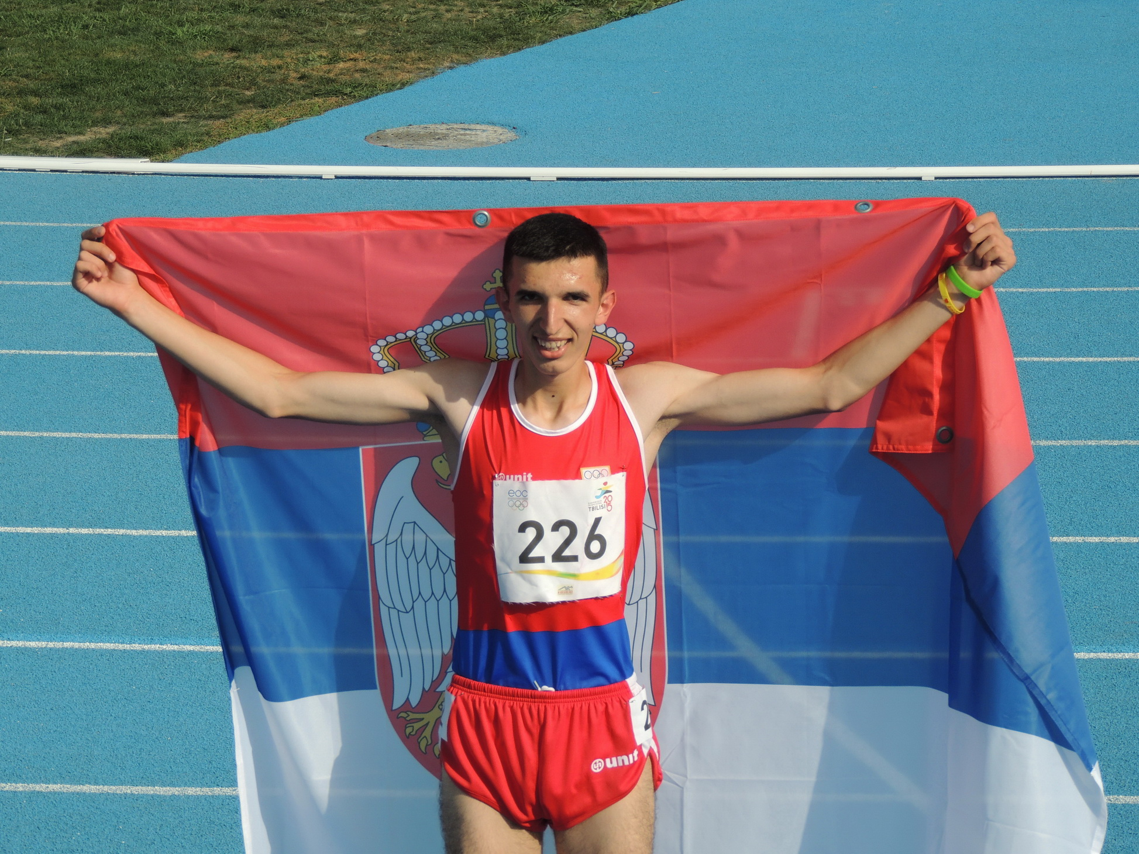

BIBIĆ Elzan ____

Rođen/Born: 8.I 1999. Novi Pazar
Visina/Height: 197cm
Težina//Weight: 70kg

Član/Member: AK Novi Pazar

Trener/Coach: Rifat Zilkić

Razvoj/Year Progression
(800/1500/3000m)

2014- 2:01,52/4:11,41/8:51,7
2015- 1:58,70/3:57,02/8:19,3
2016- 1:51,16/3:47,40/8:01,92-8:09,06i
2017- 3:57,28/8:18,82-8:06,98i;
2018- 1:51,58/3:37,79/7:51,51;
2019- 1:50,80/3:37,66/7:53,16;

Lični rekordi/PBS
5000- 13:34,99 (2019); 10000- 30:32,87 (2017); indoor: 1500- 3:43,13 (2019); 3000- 7:55,14 (2019);

Svetsko prvenstvo za juniore/World Junior Championship
2016- 1500 3:51,58 XI (3:47,72 Q); 5000 13:51,40 VIII; 2018- 1500 3:44,65 VI (3:44,68 sf); 5000 14:15,37 VIII;

Prvenstvo Evrope u dvorani/European Indoor Championship
2019. 1500 (3:47,94 Q);

Prvenstvo Evrope u krosu/European Cross-Country Championship
2015- 28. mesto jun.; 2016- 28. mesto jun.; 2017- 31. mesto jun.; 2018- BRONZ jun.; 2019. SILVER ml.seniori/U23;

Pvrnestvo Evrope za mlađe seniore/European U23 Championship
2019. 1500 3:50,90 (3:47,61 Q) BRONZ; 5000- 14:26,80 VIII;

Prvenstvo Evrope za mlađe juniore/Euroepan Youth Championship
2016- 800 (1:56,12) VIII (1:51,16 sf, 1:54,93Q); 3000 (8:09,06) GOLD

Evropski dani mladih (EYOF)
2015- 1500 4:01,62 (sf 4:03,60) SILVER; 3000 (8:50,10) GOLD;

Mediteranske igre/Mediterranean Games
2018- 5000 14:32,05 XIII;

Prvak Balkana/Balkan Champion
2015- 3000 (8:37,36 mj/youth); 2016- 3000 (8:16,72); (8:16,86 mj/youth); 2017- 3000 (8:06,98); 2018- 3000 8:08,34; 3000 (8:21,45 jun); 1500 (3:46,89 jun); 3000 (8:17,60 jun); 1500 3:43,36; 3000 8:15,06; kros jun.; 2019- 1500 (3:43,13 indoor); kros ml.seniori;

Prvak Srbije/Serbian Champion
2014- 1500 (4:13,99 mj/youth); 2015- 1500 (4:01,37 mj/youth); 3000 (8:55,04 mj/youth); kros (mj/youth); 2016- 1500 3:52,65; 2017- kros jun.; 2018- 1500 (3:46,04); (3:46,45 jun); 3:51,89 (indoor); 3000 (8:06,43 indoor); kros jun.; 2019. 800 1:50,80; 1500 3:45,63; indoor: 1500 3:46,55; 3000 8:05,47; kros ml.seniori;

Državni rekorder/Serbian National Record Holder
seniori: 1500- 3:43,13 (dvorana/indoor 2019); juniori: 1500- 3:37,79 (2018); 3000- 7:51,51 (2018); indoor: 3000- 8:09,06 (2016); 8:06,98 (2017); 8:06,43 (2018); 5000- 13:51,40 (2016); 13:44,25 (2018); mlađi juniori: 800- 1:51,16 (2016); 1500- 3:47,40 (2016); 3000- 8:01,92 (2016); 5000- 13:51,40 (2016);

DOKUMENTACIJA:
Ljubiša Gajić (Jagodina)
ATFS Serbia

