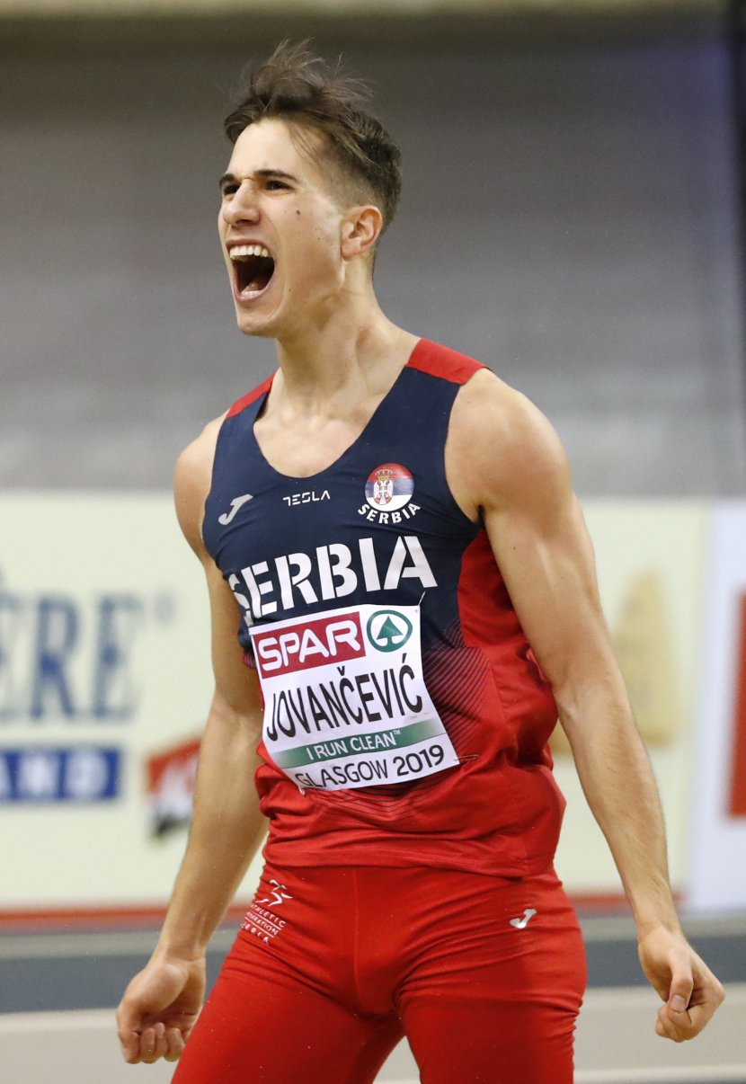

JOVANČEVIĆ Strahinja ____

Rođen/Born: 28.II 1993. Beograd
Visina/Height: 183cm
Težina/Weight: 65kg

Član/Member: AK Crvena zvezda (Beograd)

Trener/Coach: Milorad Jovančević (father)

Razvoj/Year Progression
(skok u dalj/long jump)

2010- 6,13
2011- 7,10
2012- 7,52
2013- 7,38
2014- 7,61/7,71w/7,64i
2015 – 7,46
2016 – 7,92
2017 – 7,81
2018 – 7,98
2019 – 8,03i

Lični rekordi/PBS
100- 10,75 (2014); 200- 22,26 (2013); indoor: 60- 6,94 (2014); dalj- 8,03 (2019)

Prvenstvo Evrope/European Championship:
2018 – 7,69 Q;

Prvenstvo Evrope u dvorani/European Indoor Championship:
2019 – 8,03 BRONZ (Q 7,73);

Univerzijada/Universiade
2017 – 7,52 VIII (Q 7,63)

Balkanske igre/Balkan Games:
Prvak/winner: 2016 – 7,92;

Rekorder Srbije/Serbian Record Holder
indoor: LJ – 8,03 (2019);

Prvak Srbije/Serbian Champion
2014 – 7,38; 2018 – 7,64;

DOKUMENTACIJA
Ljubiša Gajić (Jagodina)
ATFS Serbia

