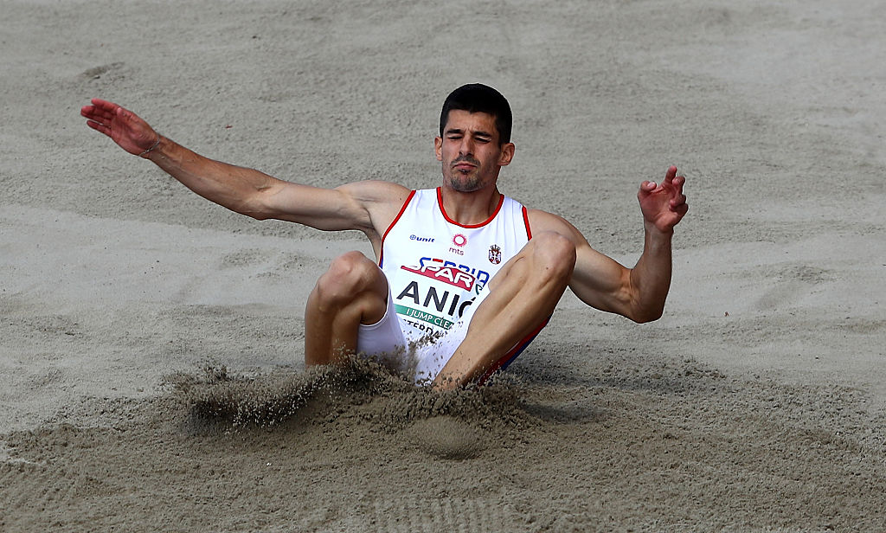

ANIĆ Lazar ____

Rođena/Born: 14.XII 1991. Kragujevac
Visina/Height: 188cm
Težina/Weight: 78kg

Član/Member: AK Radnički (Kragujevac)

Trener/Coach: Željko Obradović

Razvoj/Year Progression
(skok u dalj/long jump)

2008- 13,68 (TJ)
2009- 6,72
2010- 7,08
2011- 7,14
2012- 7,50
2013- 7,39
2014- 7,54
2015 – 7,60
2016 – 7,98
2017 – 8,15/7,98i
2018 – nm/7,62i

Lični rekordi/PBS
100- 11,04 (2014); troskok- 15,24 (2015); indoor: 60- 7,10 (2013); dalj- 7,98 (2017); troskok- 15,30 (2016);

Svetsko prvenstvo/World Championship
2017. 7,71 Q

Prvenstvo Evrope/European Championship:
2016 – 7,63 X (Q 7,93;

Prvenstvo Evrope u dvorani/European Indoor Championship:
2017 – 7,90 VI (Q 7,98);

Balkanske igre/Balkan Games:
Prvak/winner 2016 – 7,90 (indoor); 2017 – 7,94;

Reprezentativac Balkana/Balkan Team Member
2017 – 7,67 II;

Prvak Srbije/Serbian Champion
2012 – 7,50; 2015 – 7,50; TJ – 15,24; 2016 – 7,98; 2017 – 7,82;

DOKUMENTACIJA
Ljubiša Gajić (Jagodina)
ATFS Serbia

