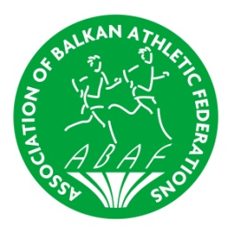
10 th Balkan Mountain Running Championships
VRNJAČKA BANJA / SERBIA, 05 May 2018


GENERAL PROGRAMME

FRIDAY 04. may 2018.
All day | Arrival of Teams to Vrnjačka Banja (www.ivrnjackabanja.com)  Accommodation in Hotel Banbus (http://www.banbus.co.rs/letovanje/srbija-letovanje/vrnjacka-banja-leto/turisticko-ugostiteljski-centar-banbus.html)
18.30 -19.15 | Opening Ceremony in hotel Banbus Vrnjačka Banja
20.00 - 20.45 | Technical Meeting in hotel Banbus Vrnjačka Banja
21.00 – 23.00 | Official Dinner – hotel Banbus Vrnjačka Banja
SATURDAY 05. may 2018.
09.00 | Start U20 Women (3 loops, 6 km +300m/-300m)
10.15 | Start U20 Men (3 loops, 6 km + 300m/-300m)
11.30 | Start Senior Women (5 loops, 10 km + 500m/-500m)
13.00 | Start Senior Men (6 loops 12 km +600m/-600 m )
17.30 -18.30 | Victory Ceremonies in Hotel Banbus
20.00 – 23.00 | Dinner and Final Party at Hotel Banbus
SUNDAY 06. may 2018.
08.00 - | Departure of Teams

