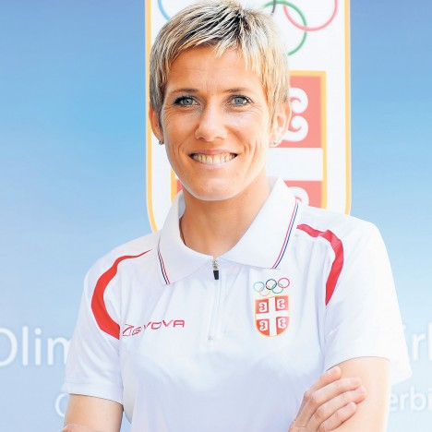

JEVTIĆ Olivera

Rođena/Born: 24.7.1977 Užice
Visoka/Height: 174cm
Teška/Weight: 54kg

Član/Member: AK Mladost (Užice)
Trener/Coach: Slavko Kuzmanović

Razvoj/Year Progression:
(3/5/10km/Marathon)

1992- 9:39,1
1993- 9:24,38
1994- 9:13,97
1995- 9:14,71/16:03,34/33:48,61
1996- 9:06,95/15:40,59/32:38,0
1997- 9:09,3/15:34,65/32:43,42
1998- 8:59,21/15:16,61/31:34,26
1999- 9:02,95/15:19,08/31:57,67
2000- 15:11,25/31:29,65
2001- 15:26,84/31:33,08
2002- 15:40,24/31:47,81/1:09:18/2:26:44
2003- x/x/2:25:33
2004- 15:33,37/2:27:34
2005- x/x/2:31:43
2006- x/x/2:29:38
2007- x/x/2:35:46
2008- 15:25,34/x/2:40:05
2009- 15:28,38/31:35,92/2:31:18
2010- 15:37,67/2:34:56
2011- 1:13:12 (HM)
2012- 1:17.21/2:37:58
2013- 9:29,54/15:55,74/32:52,56/1:14:39/
2:36:13
2014- 17:16,20/34:50,29/1:15:48/2:38:22

2015- 2:39:32
2016- 16:21,14/1:12:25 (HM)
2017- 16:22,66/2:35:31

Lični rekordi/PBS:
800- 2:12,41 (1993); 1500- 4:16,16 (1998); HM- 69:18 (2002).

Olimpijske igre/Olympic Games:
2000- 5km dnf; 10km: 31:29,65 XI; 2004- Mar: 2:31:15 VI; 2008- Mar: dnf; 2012- Mar: dnf; 2016- Mar: dnf;

Svetska prvenstva/World Championship:
1997- 5km: 15:43,76 Q; 10km- 33:18,42 Q; 1999- 10km: 31:57,67 X; 2001- 5km: 15:29,61 Q; 10km- 32:19,44 XII; 2003- Mar: 2:26:49 VIII

Svetska prvenstva u krosu/World Cross-Country Championship:
1997- 51; 2000- 15; 2001- IX; 2004- 12;

Svetska prvenstva u polumaratonu/World Halfmarathon Championship:
1998- 70:02 IV; 1999- 72:32 XXI; 2001- 69:51 VII; 2002- 69:33 VI; 2009. 72:44 XXVIII

Prvenstvo Evrope/European Championship:
1998- 5km: 15:16,61 IV; 10km- 31:34,26 IV; 2002- 5km: dnf; 10km: 31:47,82 VI; 2006- Mar: 2:30:27 SILVER; 2010- Mar: 2:34:56 V; 2016- Hmar: 1:13:39 XXVIII;

Prvenstvo Evrope u krosu/European Cross-Country Championship:
1997- BRONZ; 1998- BRONZ; 1999- BRONZ; 2000- BRONZ; 2001- IV; 2003- VI; 2005- IV; 2006- BRONZ; 2009- VII; 2011- XXI; 2012- XXVI; 2014- XXXII;

Kup Evrope na 10km/European Cup 10km
2009- II mesto 31:35,92; 2013- III mesto 32:52,56

Prvenstvo Evrope za ml.seniorke/European U-23 Championship:
1997- 10km: 32:44,22 GOLD; 1999- 5km: 15:24,8 BRONZ; 10km- 32:37,59 GOLD;

Rekord Evrope za ml.seniorke/Euroepan U-23 Record Holder:
10km: 32:37,59 (1999)

Mediteranske igre/Mediterranean Games
1997- bronz (10km 32:43:42); IV (5km 15:38,12); 2001- silver (10km 31:33,08) bronz (5km 15:40,61); 2005- bronz (10km 33:30,24); bronz (HM- 1:16:32); 2009- bronz (10km 32:23,06)

Prvak Balkana/Balkan Games Winner
1996- 10km 32:38,0; 1997- kros; 1998- 5km 15:32,54; kros; 1999- kros; 2000- kros; 2002- kros; 2004- kros; 2009- Mar 2:31:18; 2011-kros; 2013- Polumaraton/HM 1:14:39; 2015- Mar 2:39:32; 2016- Hmar 1:12:25; 2017- Mar 2:35:31

Svetsko prvenstvo za juniorke/World Junior Championship:
1994- 3km: 9:29,14 X; 1996- 3km: 9:06,95 V; 5km: 15:40,59 SILVER;

Prvenstvo Evrope za juniorke/European Junior Championship:
1995- 3km: 9:15,61 BRONZ; 10km: 33:48,61 SILVER;

Rekordi Jugoslavije/Yugoslav Record Holder:
5km: 1995- 16:03,34; 1996- 15:55,18; 15:40,59; 1997- 15:34,65; 1998- 15:16,61; 10km: 1999- 31:34,26; 2000- 31:29,65; Hmar: 1998- 70:02; 2001- 69:34; 2002- 69:18; Mar: 2003- 2:25:33.

DOKUMENTACIJA
Ljubiša Gajić (Jagodina)
(ATFS Serbia)

